Digital Egypt Pioneers Initiative رواد مصر الرقمية
Round 4 الدورة الرابعة
2025 - 2026 2025 - 2026

Track: AI & Data Science - Microsoft Machine Learning Engineer
Group Code: ONL4_AIS2_S7
Instructor: Eman Elgalad
Company Name: Skills Dynamix



Project Name

"AI-Powered Predictive Maintenance for Industrial Equipment"
No. | Name
1 | Moaz Osama Esamil Hataba (TL)
2 | Abrar Ashraf Shaban Ahmad
3 | Marwan Muhammad Darwish Ammar
4 | Yussef Ahmad Muhammad Elshamy
5 | Salma Muhammad Nageh Abdul-Hamid
6 | Nour-Eldin Kamel Muhammad Hasanein

Task |  | Page No. | Evaluation
Entity-Relationship Diagram |  | 5
Logical Schema |  | 6
Physical Schema |  | 7
Normalization |  | 9

System Analysis
&
Design
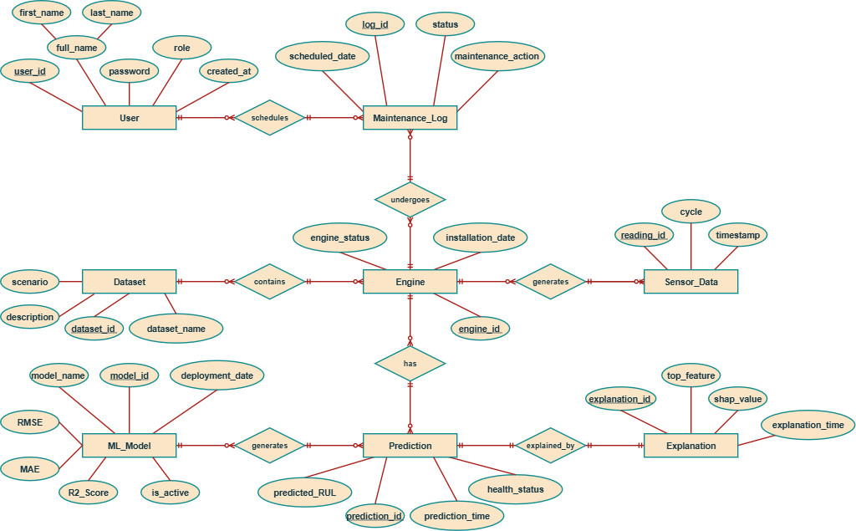
Entity-Relationship Diagram (ERD):
Logical Schema:
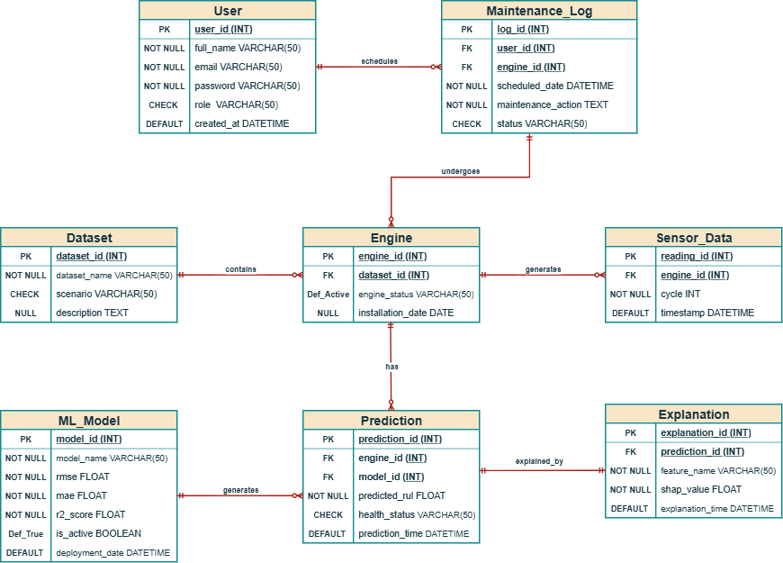
Physical Schema:
- USER TABLE
CREATE TABLE User (
user_id INT PRIMARY KEY AUTO_INCREMENT,
full_name VARCHAR(100),
email VARCHAR(100) UNIQUE NOT NULL,
password VARCHAR(255) NOT NULL,
role VARCHAR(50),
created_at DATETIME DEFAULT CURRENT_TIMESTAMP
);
- MAINTENANCE LOG TABLE
CREATE TABLE Maintenance_Log (
log_id INT PRIMARY KEY AUTO_INCREMENT,
user_id INT,
engine_id INT,
scheduled_date DATE,
maintenance_action TEXT,
status VARCHAR(50),
FOREIGN KEY (user_id) REFERENCES User(user_id),
FOREIGN KEY (engine_id) REFERENCES Engine(engine_id)
);
- DATASET TABLE
CREATE TABLE Dataset (
dataset_id INT PRIMARY KEY AUTO_INCREMENT,
dataset_name VARCHAR(100),
scenario VARCHAR(10),
description TEXT
);
- ENGINE TABLE
CREATE TABLE Engine (
engine_id INT PRIMARY KEY AUTO_INCREMENT,
dataset_id INT,
engine_status VARCHAR(50),
installation_date DATE,
FOREIGN KEY (dataset_id) REFERENCES Dataset(dataset_id)
);
- SENSOR DATA TABLE
CREATE TABLE Sensor_Data (
reading_id INT PRIMARY KEY AUTO_INCREMENT,
engine_id INT,
cycle INT,
timestamp DATETIME,
FOREIGN KEY (engine_id) REFERENCES Engine(engine_id)
);
- ML MODEL TABLE
CREATE TABLE ML_Model (
model_id INT PRIMARY KEY AUTO_INCREMENT,
model_name VARCHAR(100),
RMSE FLOAT,
MAE FLOAT,
R2_Score FLOAT,
deployment_date DATE,
is_active BOOLEAN
);
- PREDICTION TABLE
CREATE TABLE Prediction (
prediction_id INT PRIMARY KEY AUTO_INCREMENT,
engine_id INT,
model_id INT,
predicted_RUL FLOAT,
health_status VARCHAR(50),
prediction_time DATETIME,
FOREIGN KEY (engine_id) REFERENCES Engine(engine_id),
FOREIGN KEY (model_id) REFERENCES ML_Model(model_id)
);
- EXPLANATION TABLE
CREATE TABLE Explanation (
explanation_id INT PRIMARY KEY AUTO_INCREMENT,
prediction_id INT,
top_feature VARCHAR(100),
shap_value FLOAT,
explanation_time DATETIME,
FOREIGN KEY (prediction_id) REFERENCES Prediction(prediction_id)
);
Normalization:
- Unnormalized Form (UNF)
  - Initially, all information could be stored in a single table.
  - This table contains:
    - UserID.
    - UserName.
    - Role.
    - Dataset.
    - EngineID.
    - Cycle.
    - Sensor1 – 21.
    - PredictedRUL.
    - HealthStatus.
    - SHAPFeature.
    - SHAPValue.
    - ModelName.
    - RMSE.
    - MAE.
    - R².
    - MaintenanceAction.
  - Problems
    - Data redundancy.
    - Update anomalies.
    - Insert anomalies.
    - Delete anomalies.
    - Multiple unrelated entities stored together.
UserID | UserName | Role | Dataset
EngineID | Cycle | Sensor1 – 21 | PredictedRUL

RMSE | MAE | R² | MaintenanceAction
HealthStatus | SHAPFeature | SHAPValue | ModelName

- First Normal Form (1NF)
  - Rule:
    - Must already satisfy 1NF.
    - Remove partial dependencies.
  - Improvement
    - Each sensor value is atomic.
    - Each reading has a unique primary key.
ReadingID (PK) | EngineID | Cycle
1 | 5 | 1
2 | 5 | 2

- Second Normal Form (2NF)
  - Rule:
    - Atomic values only
    - No repeating groups
    - Every row uniquely identified.
UserID (PK) | Name | Email | Role
  - User Table

  - Maintenance_Log Table
LogID (PK) | EngineID (FK) | UserID (FK) | Action | Status

  - Dataset Table
DatasetID (PK) | Scenario | Description

EngineID (PK) | DatasetID (FK) | Status
  - Engine Table

  - Sensor_Data Table
ReadingID (PK) | EngineID (FK) | Cycle | Sensor1 - 21

  - ML_Model Table
ModelID (PK) | ModelName | RMSE | MAE | R²

  - Prediction Table
PredictionID (PK) | EngineID (FK) | ModelID (FK) | PredictedRUL | HealthStatus

  - Explanation Table
ExplanationID (PK) | PredictionID (FK) | FeatureName | SHAPValue

- Third Normal Form (3NF)
  - Rule:
    - Must satisfy 2NF.
    - Remove transitive dependencies.
  - User Table
user_id (PK) | full_name | email | password | role | created_at

  - Maintenance_Log Table
log_id (PK) | engine_id (FK) | user_id (FK) | status | maintenance_action | scheduled_date
  - Dataset Table
dataset_id (PK) | dataset_name | Scenario | Description

  - Engine Table
engine_id (PK) | dataset_id (FK) | Status | installation_date

  - Sensor_Data Table
reading_id (PK) | engine_id (FK) | cycle | sensor1 - 21

  - ML_Model Table
model_id (PK) | model_name | rmse | mae | r2_score | deployment_date | is_active

  - Prediction Table
prediction_id (PK) | engine_id (FK) | model_id (FK) | predicted_rul | health_status | prediction_time
  - Explanation Table
explanation_id (PK) | prediction_id (FK) | feature_name | shap_value | explanation_time

